**Project Design Phase-II**

**Data Flow Diagram & User Stories**

| Date | 03 October 2022 |
| --- | --- |
| Team ID | PNT2022TMID33459 |
| Project Name | PERSONAL EXPENSE TRACKER APPLICATION |
| Maximum Marks | 4 Marks |

**Data Flow Diagrams:**

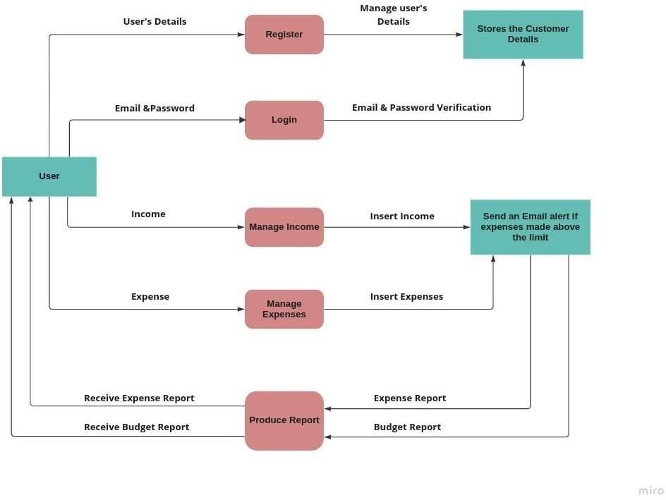

**User Stories**

| **User Type** | **Functional**  **Requirement (Epic)** | **User Story Number** | **User Story / Task** | **Acceptance criteria** | **Priority** | **Release** |
| --- | --- | --- | --- | --- | --- | --- |
| Customer (Mobile user) | Registration | USN-1 | As a user, I can register to the application by  providing my email, password, and confirming my password. | I can access my account / dashboard | High |  |
|  |  | USN-2 | As a user, I will receive confirmation email once I have registered for the application | I can receive confirmation email & click confirm | High |  |
|  | Login | USN-3 | As a user, I can log into the application by entering email & password | I can access the application | High |  |
|  | Dashboard | USN-4 | As a user I can enter my income and expenditure details. | I can view my daily expenses | High |  |
| Customer Care Executive |  | USN – 5 | As a customer care executive, I can solve the log in issues and other issues of the  application. | I can provide support or solution at any time 24*7 | Medium |  |
| Administrator | Application | USN – 6 | As an administrator I can upgrade or update the application. | I can fix the bug which arises for the customers and users of the  application | Medium |  |
| Developer | Application | UNS-7 | As a developer, getting user feedback and creating their desired update and improving application. | I can add features as per user feedback. | High |  |